

PHINMA UNION COLLEGE OF LAGUNA
Sta. Cruz, Laguna

Development of an Online Municipal Disaster Risk Reduction and Management Information System with Centralized Database for the Municipality of Luisiana, Laguna: Enhanced Community Preparedness and Resilience

Submitted by:
Aquino, Jhester M.
Custodio, Leo A.
Gallardo, James Izel P.
Manjares, Lian Rovic C.

I. Introduction
This research study is essential because it directly addresses the critical need for improved service delivery and information management at the Municipality of Luisiana. The municipality may increase staff productivity, streamline procedures, boost public happiness, and promote good governance by putting in place an information management web system. In the end, this contemporary strategy will benefit the entire community of Luisiana, Laguna, by increasing the efficacy and efficiency of municipal operations as well as fostering a more open, accountable, and citizen-centered government.
This project aims to benefit the community by providing real-time updates regarding emergencies and resources for those impacted. Essential features will encompass interactive maps, resource inventory, analytics, an incident reporting system, current news updates, warning system and a communication engagement portal for disseminating critical alerts and announcements. The design will emphasize user-friendliness and accessibility to guarantee that essential information is effectively communicated to all residents.

C. About the Team Members
- Mr. James Izel Gallardo – Project Manager: Responsible for overseeing the entire project lifecycle and ensuring its successful completion. He develops and maintains comprehensive project plans, setting timelines, milestones, and deliverables to keep the project on track. He leads a multidisciplinary team, ensuring effective communication, collaboration, and conflict resolution among team members. He allocates and manages resources, ensuring the right personnel and materials are in place and adjusting as necessary to meet evolving project demands. As the primary point of contact for stakeholders, he provides regular updates and progress reports, maintaining transparency and addressing concerns promptly.
- Mr. Leo Custodio – Lead Developer: Responsible for coding the system, implementing robust security protocols, and ensuring the overall integrity of the system. He takes the lead in designing and developing the software architecture, translating project requirements into functional, high-quality code. He works closely with the project manager (Mr. James Gallardo) and other team members to align the development process with project goals and timelines. He is also responsible for integrating security measures throughout the development lifecycle, ensuring that the system is protected against vulnerabilities and complies with industry standards.
- Mr. Jhester Aquino – Database Administrator: Responsible for managing the security, integrity, and efficiency of the database systems. His role includes overseeing database creation, maintenance, and optimization to ensure smooth operations. He also implements backup and disaster recovery plans to safeguard critical information in case of system failures or data loss.
- Mr. Lian Rovic Manjares – Quality Assurance: Responsible for conducting rigorous security testing and vulnerability assessments to identify potential risks and weaknesses. By performing penetration testing and evaluating system defenses, he ensures that security threats are detected and mitigated before they can be exploited.
- Prof. Lee Samonte – Research Capstone Adviser: Provides guidance on secure coding practices and risk management strategies. He advises on risk assessment methodologies, helping the team identify potential security risks and implement mitigation strategies. He promotes adherence to industry security standards and ensures that security considerations are integrated into the design and development process. His expertise also extends to disaster recovery planning, ensuring that the system can withstand and recover from potential cyber threats or breaches.
D. Team Members User Access Controls and Authorization To ensure secure database management, the following authorization levels are assigned:
- Mr. James Izel Gallardo - Database Administrator: Has full control of the system, including database management, security enforcement, and encryption implementation.
- Mr. Jhester Aquino - Database Manager: Manages the databases created or assigned to the project and oversees overall security enforcement.
- Mr. Lian Rovic Manjares- Database Designer: Has limited capabilities granted by managers or administrators, mainly responsible for database structure design and optimization.
- Mr. Leo Cusodio - Database Viewer: Can only view the system without making modifications, primarily for testing and verification purposes.

II. Purpose of the Project
The primary goal of the study is to create an Online Municipal Disaster Risk Reduction and Management Information Management System (MDRRMIS) for the Municipality of Lusiana, Laguna.
A. Disaster Recovery Plans
- Identify Activities
  - Maintain real-time access to disaster-related data for municipal officials and responders
  - Secure and protect critical municipal and disaster management data from potential loss or corruption.
  - Enable effective communication and coordination between MDRRM personnel, barangay captains, and community members.
- Identify Potential Issues
  - Server Failures or Crashes - Hardware or software difficulties causing system downtime.
  - Cyberattacks include DDoS attacks, malware infections, and illegal access, all of which compromise system security.
  - Data corruption refers to hardware faults, software defects, or inadvertent deletion that result in data loss.
  - Power outages - Unstable electricity that reduces server uptime, particularly during disasters.
- Determine Acceptable Downtime
  - The system should not be offline for longer than 24 hours to avoid disruptions in disaster response.
  - Critical data (such as emergency contacts, ongoing event reports, and response plans) must be recoverable within 6 hours to guarantee that municipal operations continue uninterrupted.
- Solutions and Recovery Strategies
  - Automated Daily Backups: Store all data in secure cloud storage and keep an offline backup for redundancy.
  - Secondary Backup Server - Set up a standby server that will take over if the primary system fails.
  - Employ cybersecurity measures such as firewalls and intrusion detection systems.
  - Cybersecurity Measures – Implement:
    - Firewalls are used to screen and prevent illegal access.
    - Intrusion detection systems (IDS) are used to monitor and prevent cyber threats.
    - Data encryption is used to protect sensitive information.
B. XSS (Cross-Site Scripting) Protection
- Input Validation and Sanitization - Ensure that all user inputs are validated and sanitized to eliminate potentially dangerous scripts.
- Content Security Policy (CSP) - Create a whitelist of trusted sources to prevent unauthorized scripts from being executed.
- Encoding output data prevents inserted scripts from being executed.
- HTTP-Only and Secure Cookies - Keep cookies safe from unauthorized JavaScript access and ensure secure transfer.
C. SQL Injection Protection
- Use Prepared Statements and Parameterized Queries - Prevent direct manipulation of database queries by requiring established query structures.
- Validate all user inputs to ensure that no arbitrary SQL commands are run.
- The Least Privilege Access Principle states that database rights should be limited to only those operations that are necessary for each user role.
- Error Handling and Logging - Avoid revealing database structure via error messages, and log all database-related actions for monitoring purposes.
D. Database Security Policy
- Encryption of Sensitive Data - Use AES-256 encryption for storing sensitive information like passwords and bank transactions.
- Role-Based Access Control (RBAC) - Implement a structured access control system in which users are granted permissions based on their responsibilities (for example, administrators, MDRRM personnel, and barangay captains).
- Conduct frequent security evaluations to detect and remediate any risks.
- Database Backup and Disaster Recovery - Use automated daily backups with secure offsite storage to ensure data availability in the event of a failure or attack.

E. Secure Information Flow Mode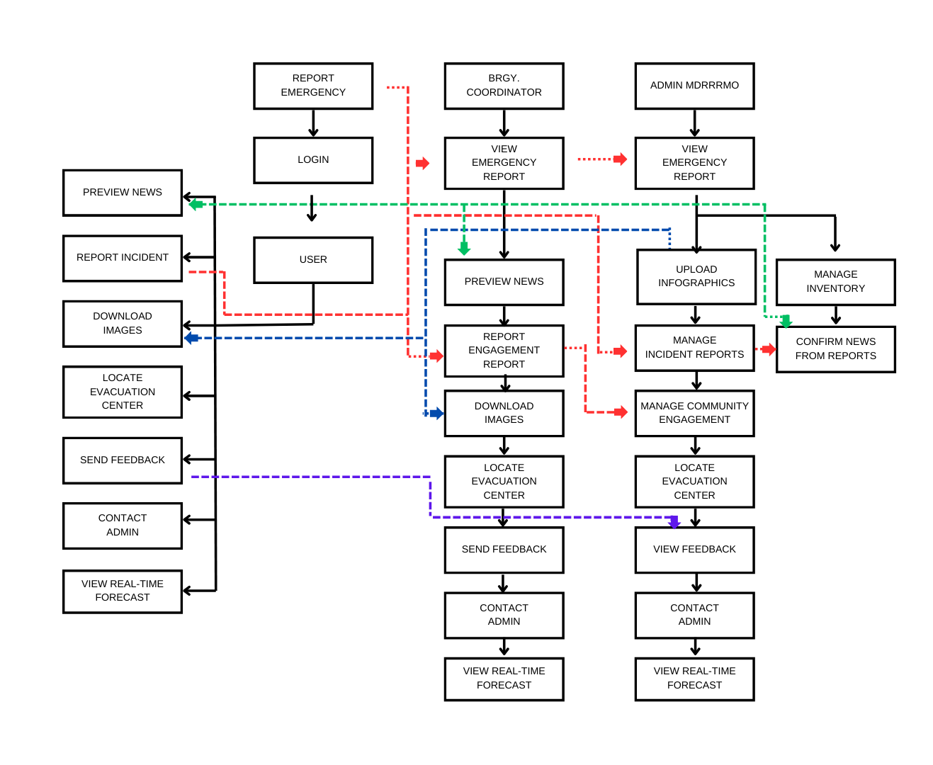
- Data Flow Diagram (DFD) illustrating secure communication paths.
- Encryption of data in transit using SSL/TLS.
- Logging and monitoring to detect anomalies in data flow.
F. Test Cases
Test Case ID | Test Case Description | Test Steps | Test Data/Input | Expected Results | Actual Results | Pass/Fail
TS1C01 | Register an account | 1. open website 2. click homepage 3. click login 4. click Sign In 5. input credentials 6. click role 7. login | username: leo  password: leo123  role: user | user has successfully go to the user dashboard |  | Pass
TS1C02 | Register an account | 1. open website 2. click homepage 3. click login 4. click sign in 5. input credentials 6. click role 7. login | username: james  password: james123  role: admin | user has successfully go to the admin dashboard |  | Pass
TS1C03 | Register an account | 1. open website 2. click homepage 3. click login 4. click sign in 5. input credentials 6. click role 7. login | username: lian  password: lian123  role: mainAdmin | user has successfully go to the mainAdmin dashboard |  | Pass
G. Encryption
- Implementation of bcrypt for password hashing.
- TLS encryption for secure communication.
H. Secured Versioning
- GitHub repository for secure version control.
- Git branching strategies for secure and organized development.
I. Securing SDLC
- Integration of security assessments at each phase of the SDLC.
- Use of threat modeling techniques during the design phase.
- Regular security code reviews and penetration testing.
III. Recommendations
A. Security Recommendations
- Regular security updates and patches to protect against new vulnerabilities.
- Continuous monitoring and logging for detecting security breaches.
- User training on secure authentication and phishing attack prevention.
- Implementation of multi-factor authentication (MFA) for system access.

